
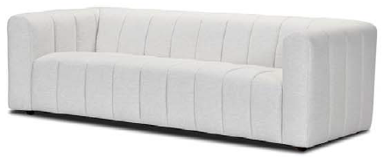

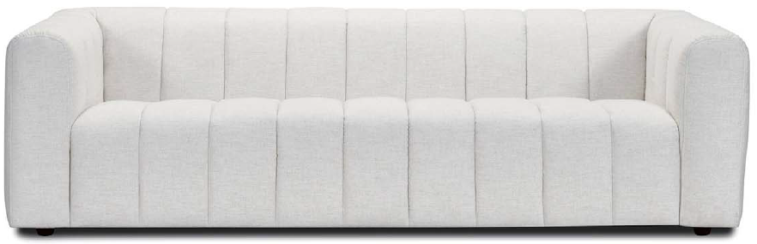

CABARET SOFA
ARMCHAIR: L 1040mm/ D 1000mm/ H 700mm

1.5 ARMCHAIR: L 1260mm/ D 1020mm/ H 700mm

2 SEATER: L 1660mm/ D 1040mm/ H 700mm

2.5 SEATER: L 1980mm/ D 1050mm/ H 700mm

3 SEATER: L 2300mm/ D 1050mm/ H 700mm

3.5 SEATER: L 2510mm/ D 1050mm/ H 700mm

Beautifully tailored with distinctive channel detailing and softly curved lines, the Cabaret Sofa brings effortless elegance to contemporary living. Its generous comfort and extensive choice of sizes allow you to create the perfect setting for your space, from a statement armchair through to a generously proportioned 3.5 seater.

TECHNICAL INFORMATION
FRAME Sustainably grown Kiln Dried Timbers and Structural Composites

SEATS Robust Elastic Webbing, with High Resilience Foam

BACKS Robust Elastic Webbing, with High Resilience Foam

FEET Timber Feet – 45mm

Made to Order in your choice of Leather or Fabric, to offer you a huge range of décor options that compliments your Interiors and Lifestyle



