
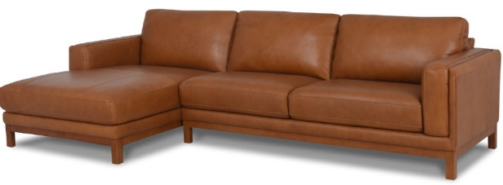

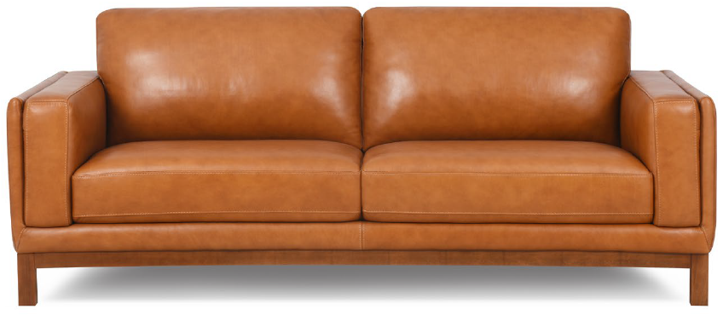

JEFFERSON SOFA
ARMCHAIR: L 1000mm/ D 910mm/ H 840mm/ SH 460mm

2 SEATER: L 1610mm/ D 910mm/ H 840mm/ SH 460mm

2.5 SEATER: L 2100mm/ D 910mm/ H 840mm/ SH 460mm

3 SEATER: L 2220mm/ D 910mm/ H 840mm/ SH 460mm

1.5 CHAISE: L 1070mm/ D 1180mm/ H 840mm/SH 460mm

2.5 SEATER 1ARM: L 1900mm/ D 910mm/ H 840mm/ SH 460mm

FOOTSTOOL: L 1900mm/ D 910mm/ H 840mm/ SH 460mm
Combining timeless elegance with contemporary sophistication, the Jefferson Sofa brings warmth and character to any living space. Beautifully tailored cushions offer inviting comfort, while the distinctive timber base adds a touch of natural refinement. Available in a choice of sofa sizes or chaise configurations, Jefferson is designed for relaxed, stylish living.
TECHNICAL INFORMATION
FRAME Sustainably grown Kiln Dried Timbers and Structural Composites

SEATS Robust No Sag Springs with High Resilience Foam

BACKS 100% Polyester Fibre Cushions

REMOVABLE CUSHIONS Yes

FEET Timber Base – 160mm

Made to Order in your choice of Leather or Fabric, to offer you a huge range of décor options that compliments your Interiors and Lifestyle


