
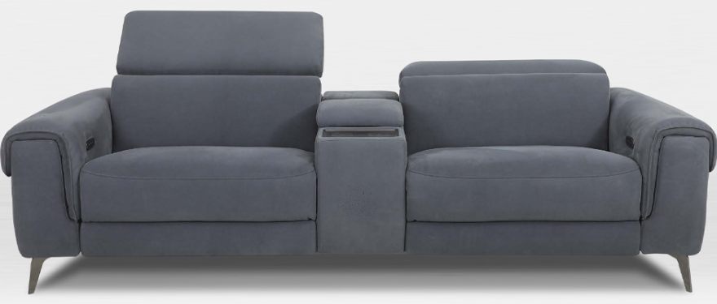

MAISON HOME THEATRE

TECHNICAL INFORMATION
FRAME Sustainably grown Kiln Dried Timbers and Structural Composites
SEATS Robust No Sag Springs with High Resilience Foam around Coil Springs
BACKS Robust Elastic Webbing, with Foam and Fibre Filled Cushions
FEET Metal – 14cm

Made to Order in your choice of Leather or Fabric, to offer you a huge range of décor options that compliments your
Interiors and Lifestyle

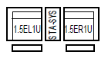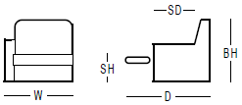

MAISON HOME THEATRE DRAWINGS



